**Assignment 3: Linux Services**

**Assignment Summary:**  
  
In this assignment, I transitioned BeesKnees Inc.’s web, file sharing, and FTP services from a Windows-based environment to a Linux-based platform to evaluate its suitability for future infrastructure. I joined the Linux server to the existing Windows domain using Kerberos, verified domain integration with user resolution tools, and configured Apache, ProFTPD (with SSL), and Samba for internal service delivery. The Linux server hosted two secure websites with proper DNS records—one publicly accessible for user data entry (with DB integration), and one restricted to specific users. File shares were created with fine-grained access control: “honeytoo” was read-only for all, while “stinger” was read-write for select users.

This project strengthened my Linux system administration skills, particularly in integrating Linux services within an Active Directory environment. I gained hands-on experience with domain joining via realm, managing Samba shares with ACLs, configuring SSL-enabled FTP and web services, and using tools like Putty and RSAT from a Windows client for remote management. This cross-platform implementation deepened my understanding of enterprise-grade hybrid networks. Based on flexibility, control, and resource efficiency, I recommended Linux as the preferred platform for web and file services.

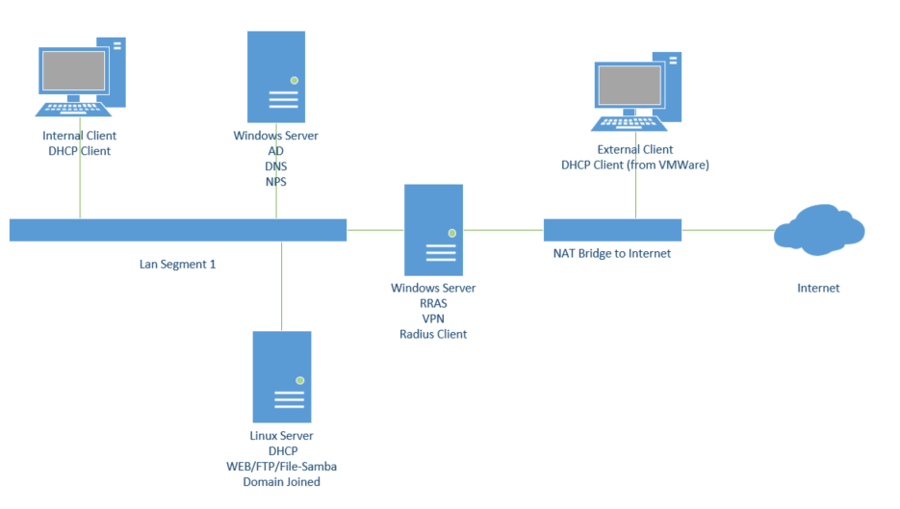

**Internal Client**

==When logged in as the domain Administrator==

**Open server manager from the RSAT tools and show:**

Both servers added to server manager

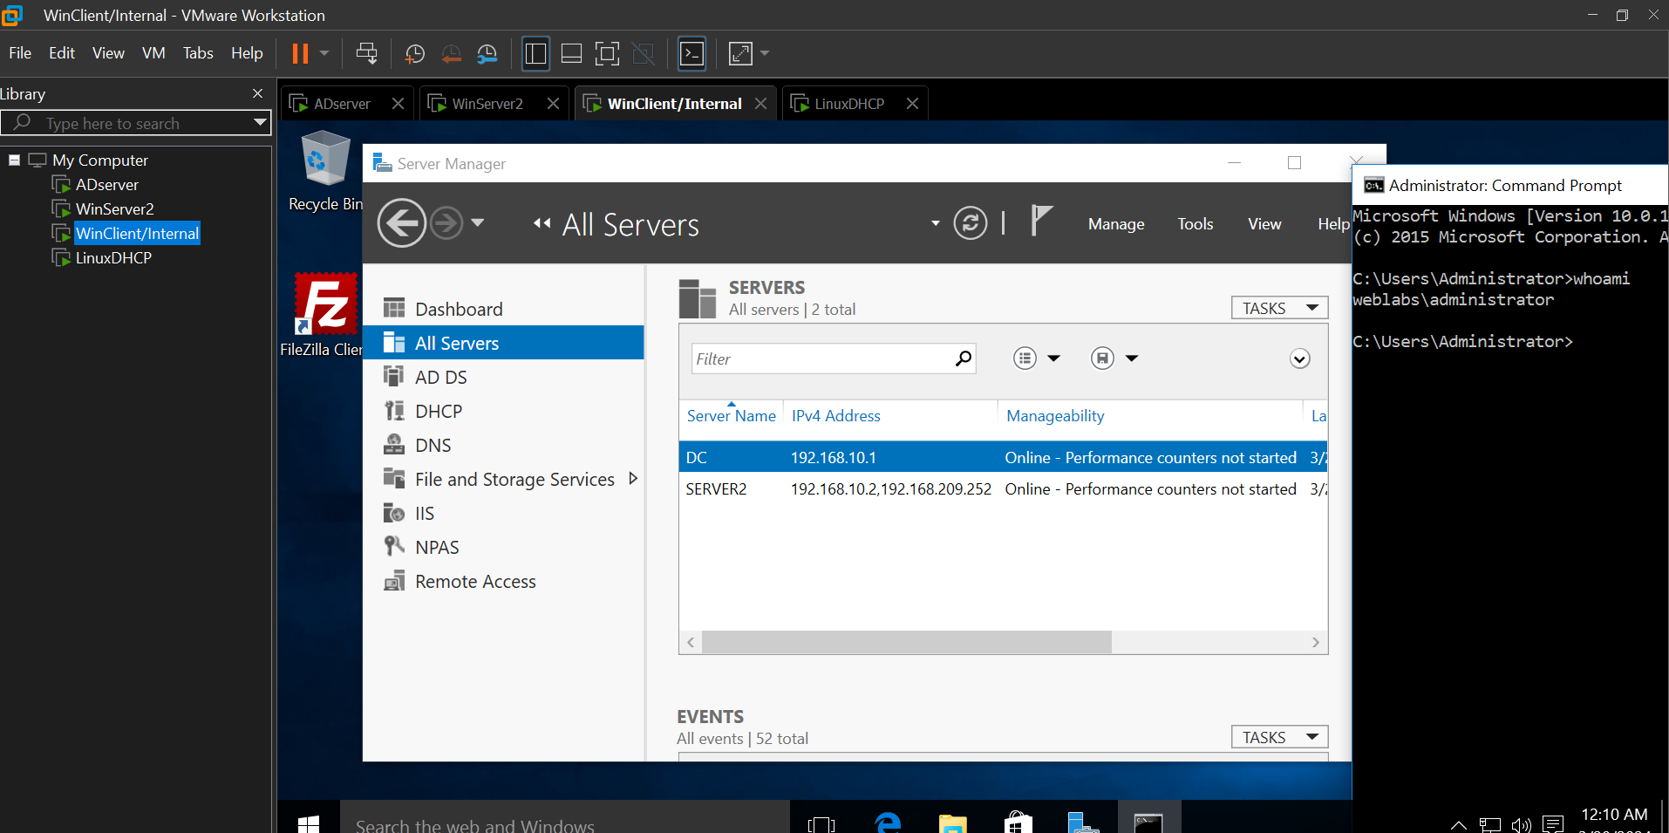

AD Users and Computers, showing the Linux machine in the domain

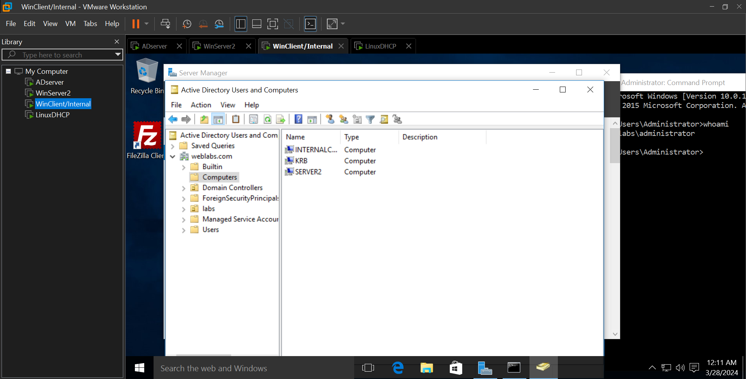

**ssh to the Linux machine as a domain user, once connected, “su -l” as root, then show the following:**

Output of “*id*” command for erica@yourdomain

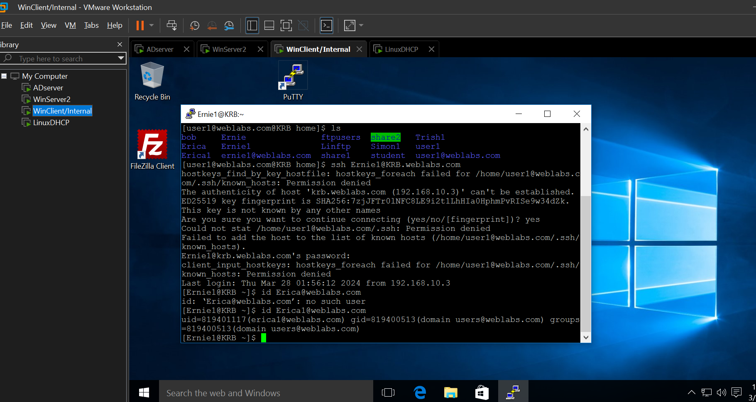

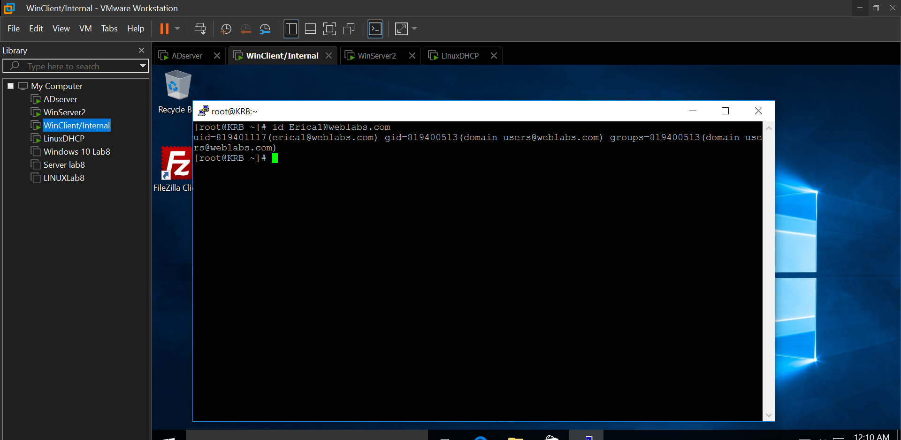

Show apache virtual directory and configuration of websites – clearly show how the bindings have been accomplished

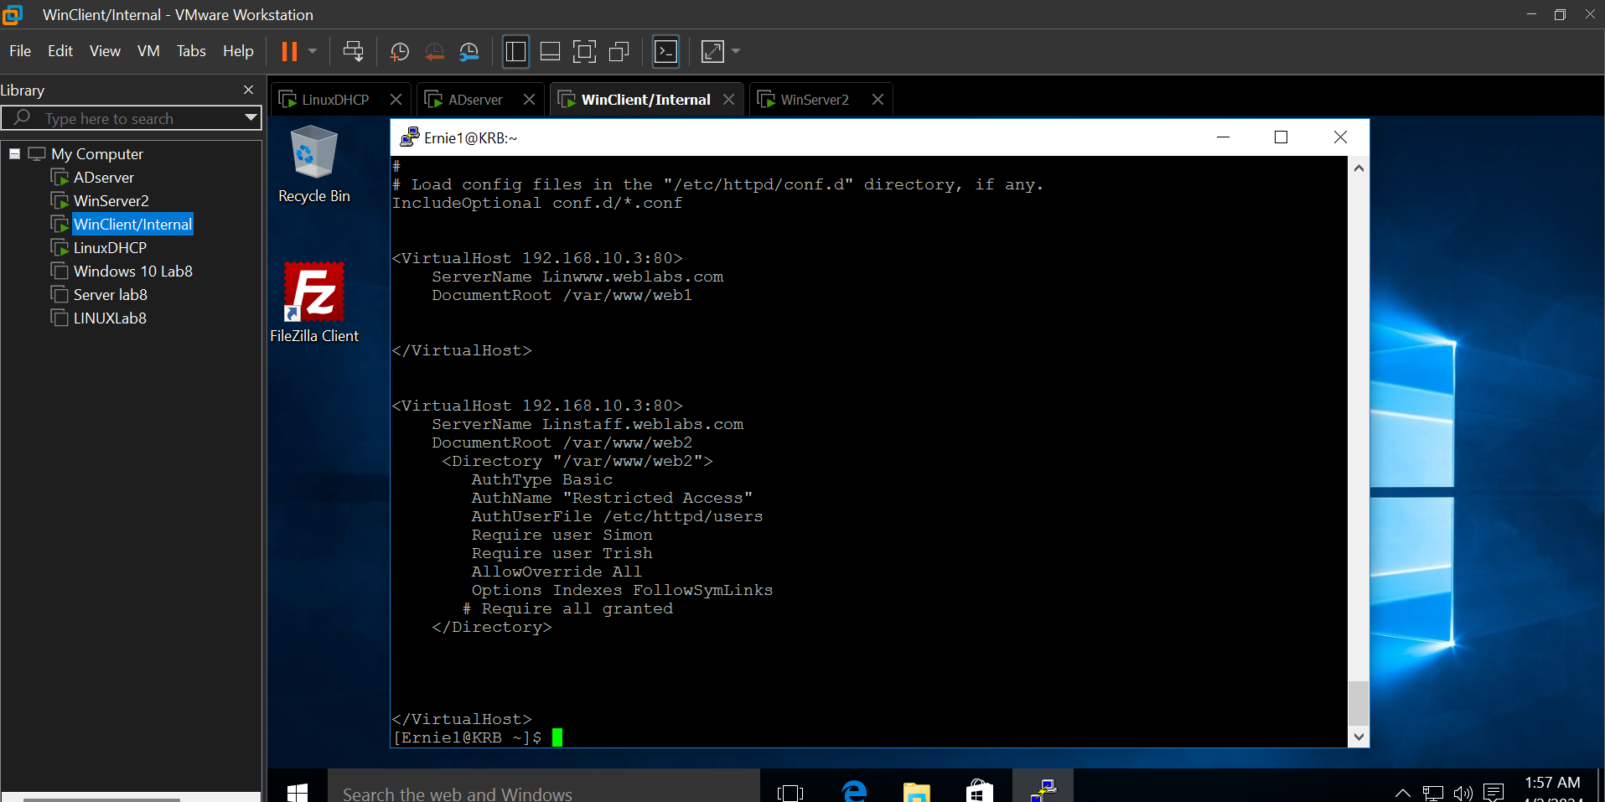

Configuration of ftp site, including certificate settings

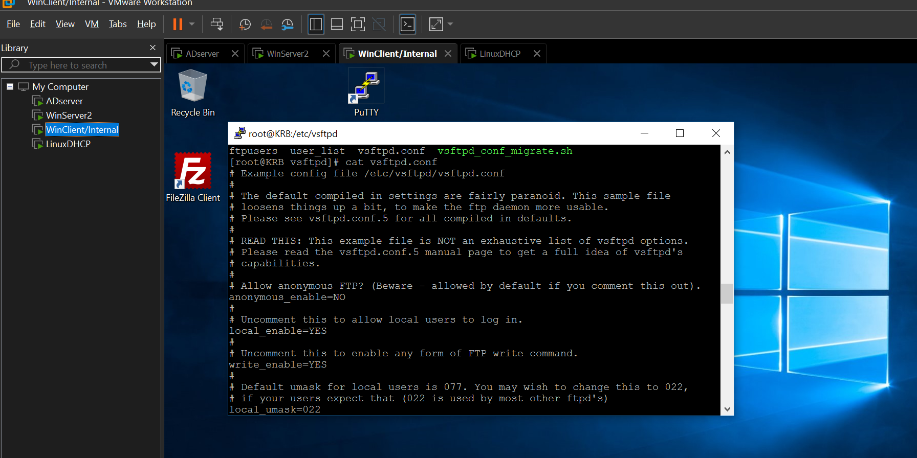

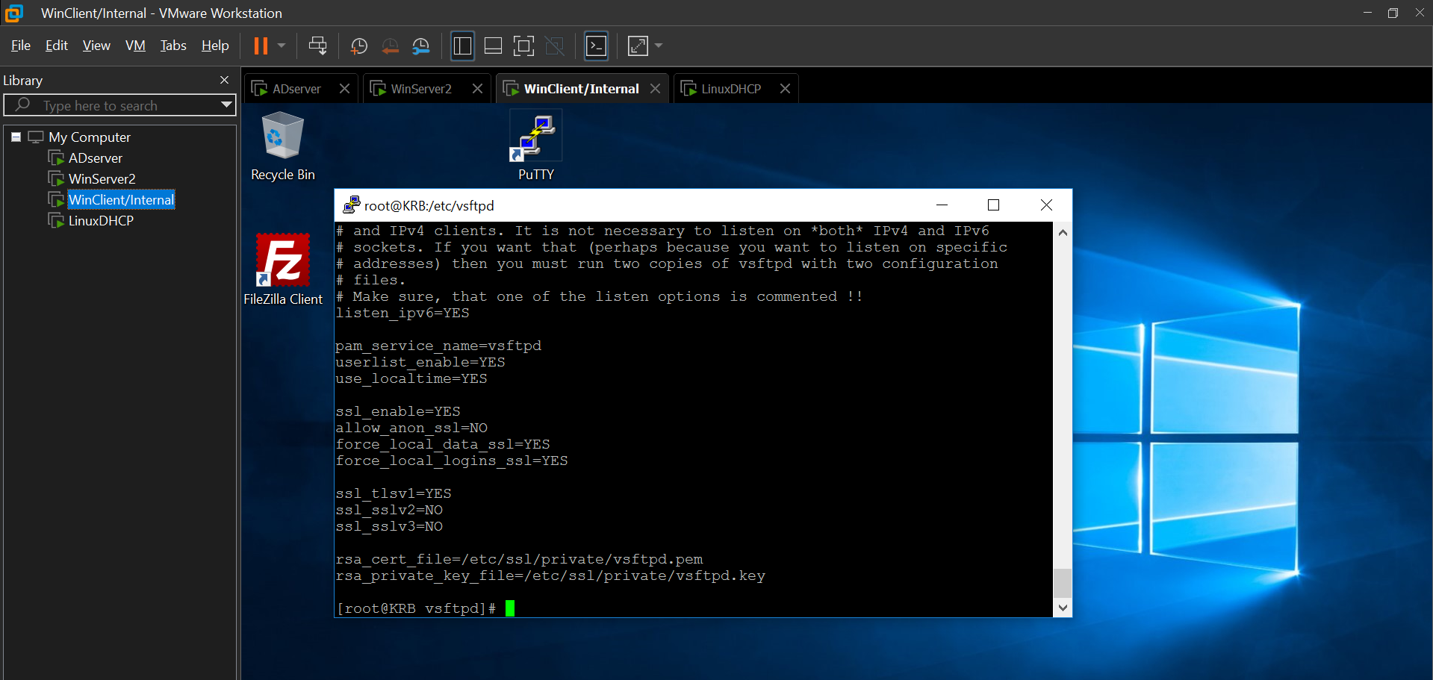

SMB configuration for shares created

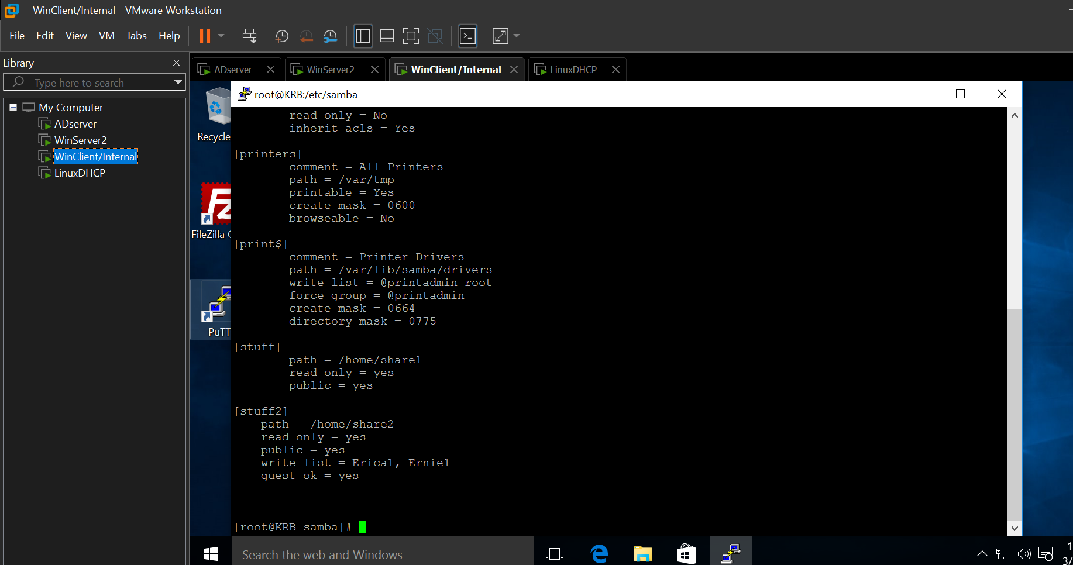

Output of “*testparm”* command

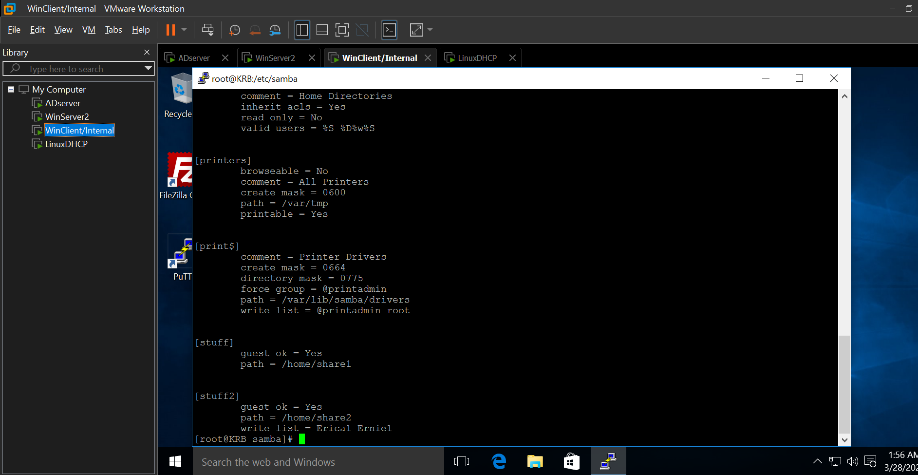

Output of “*realm list*” command

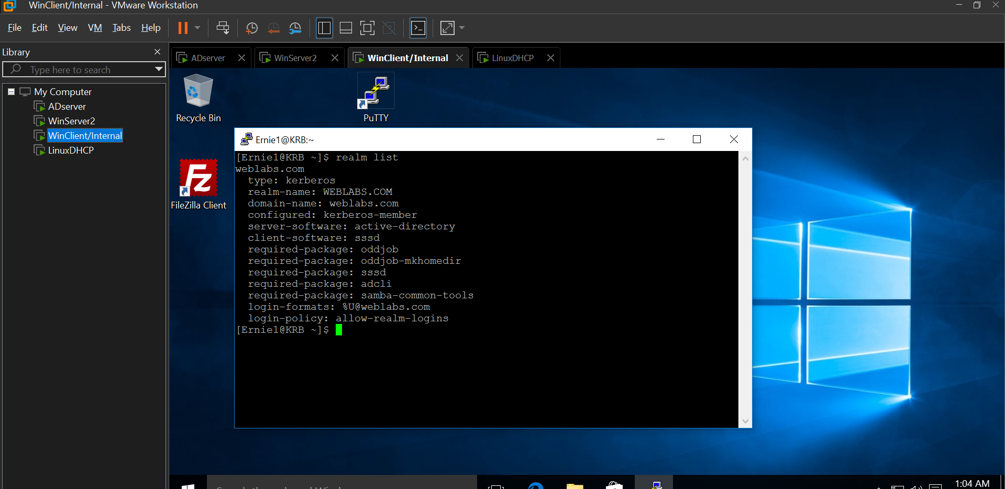

File permissions on the folders which are holding the FTP and apache content

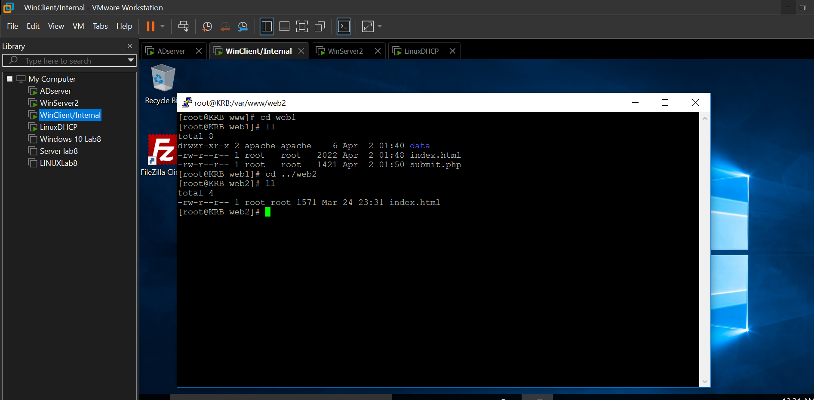

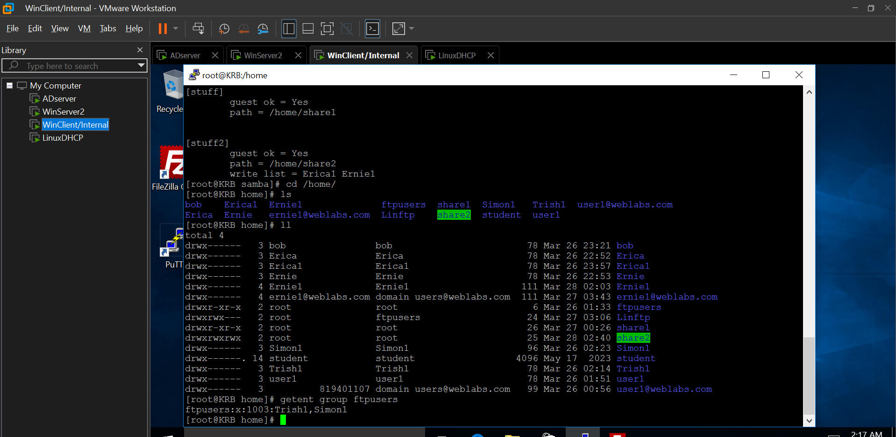

==When logged in as Trish==

“*whoami*” from command line

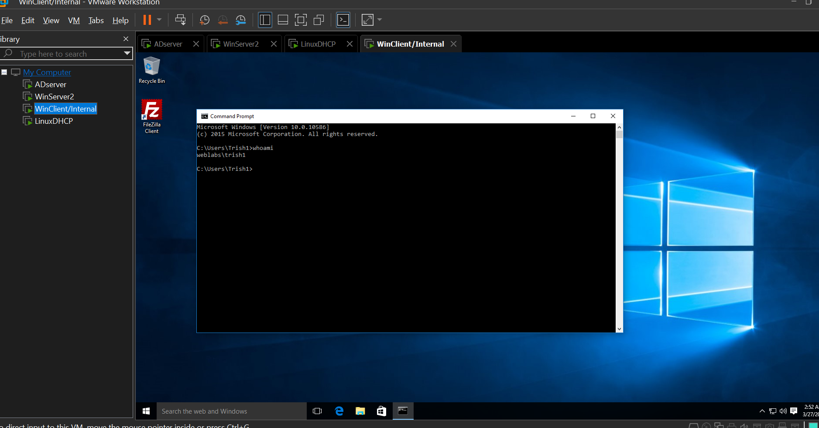

Accessing Linwww website– including login prompt and the ability to add a user to database

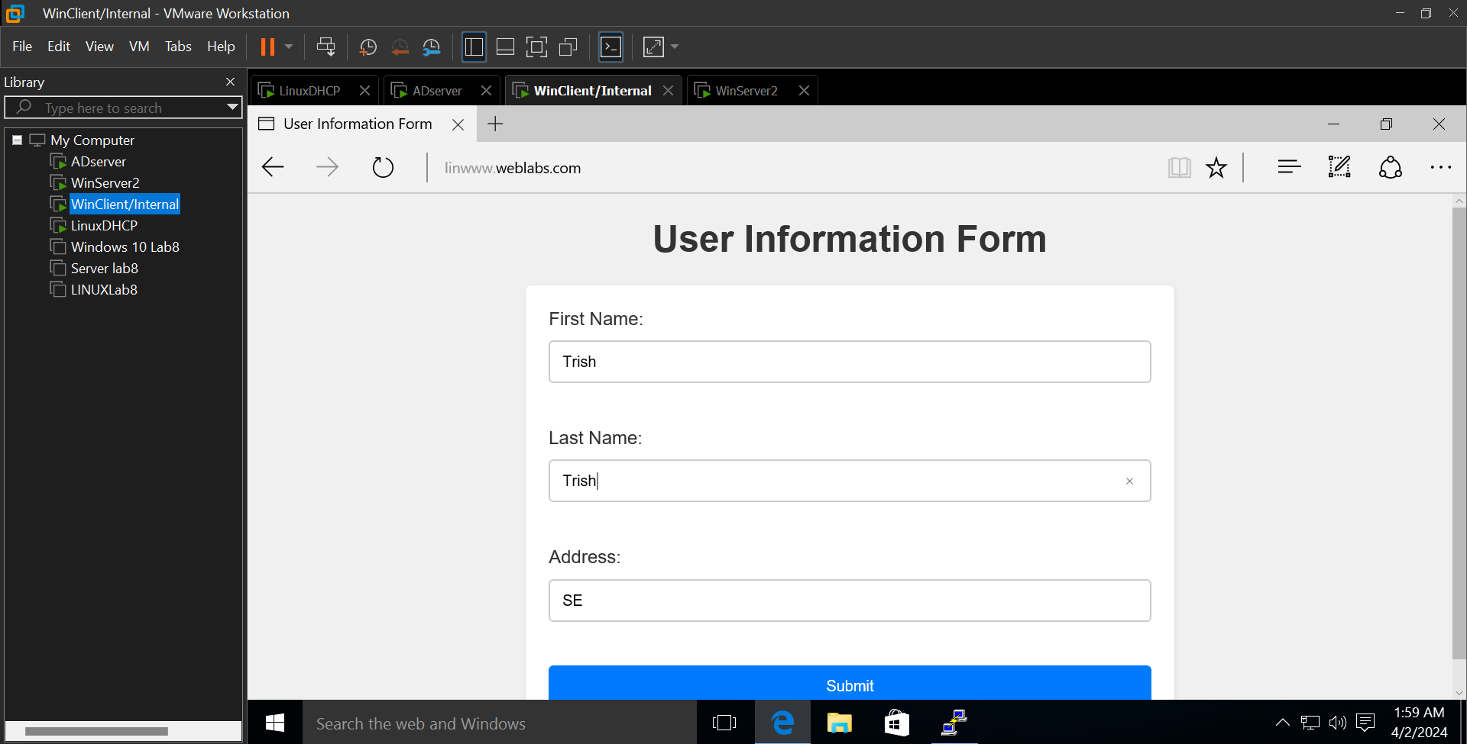

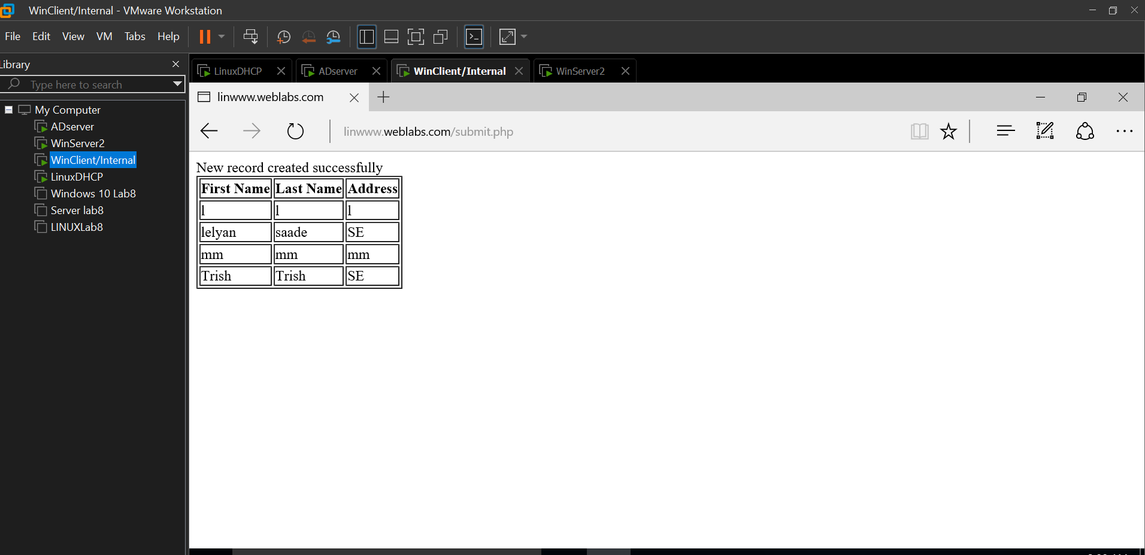

Accessing Linstaff

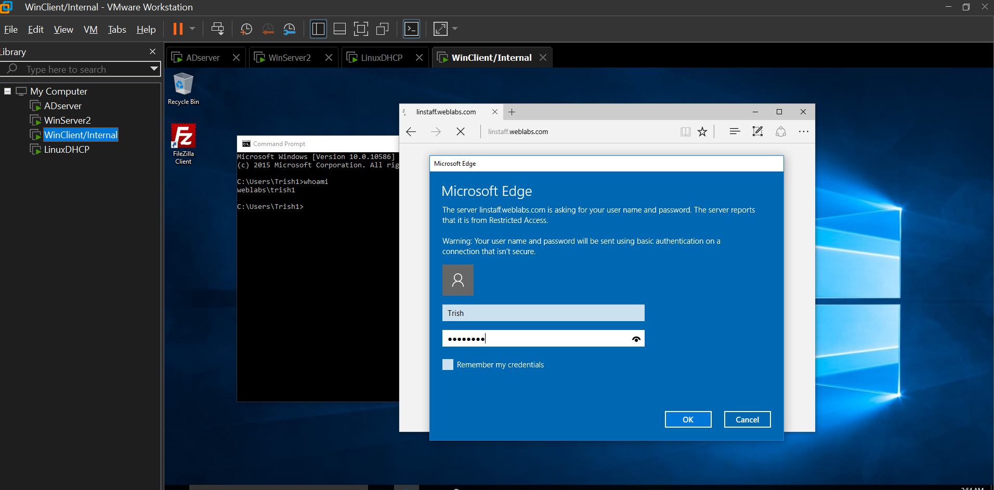

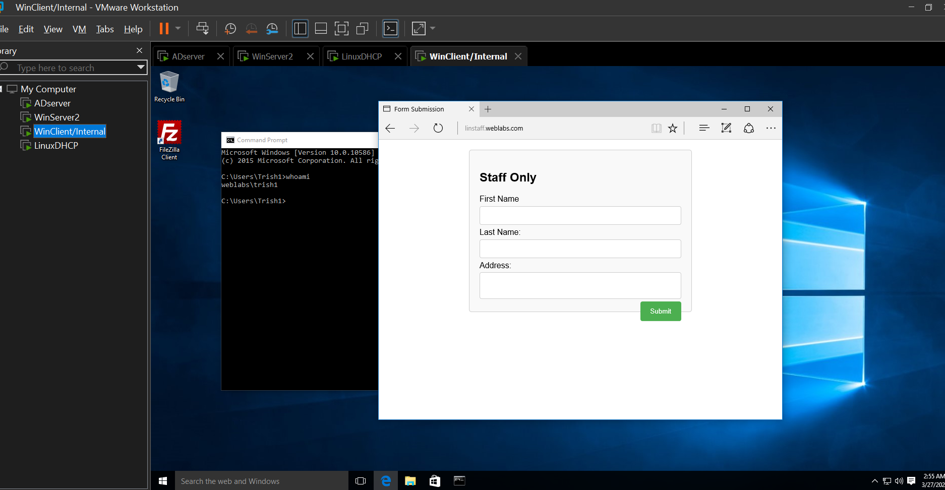

Accessing Linftp – show ability to write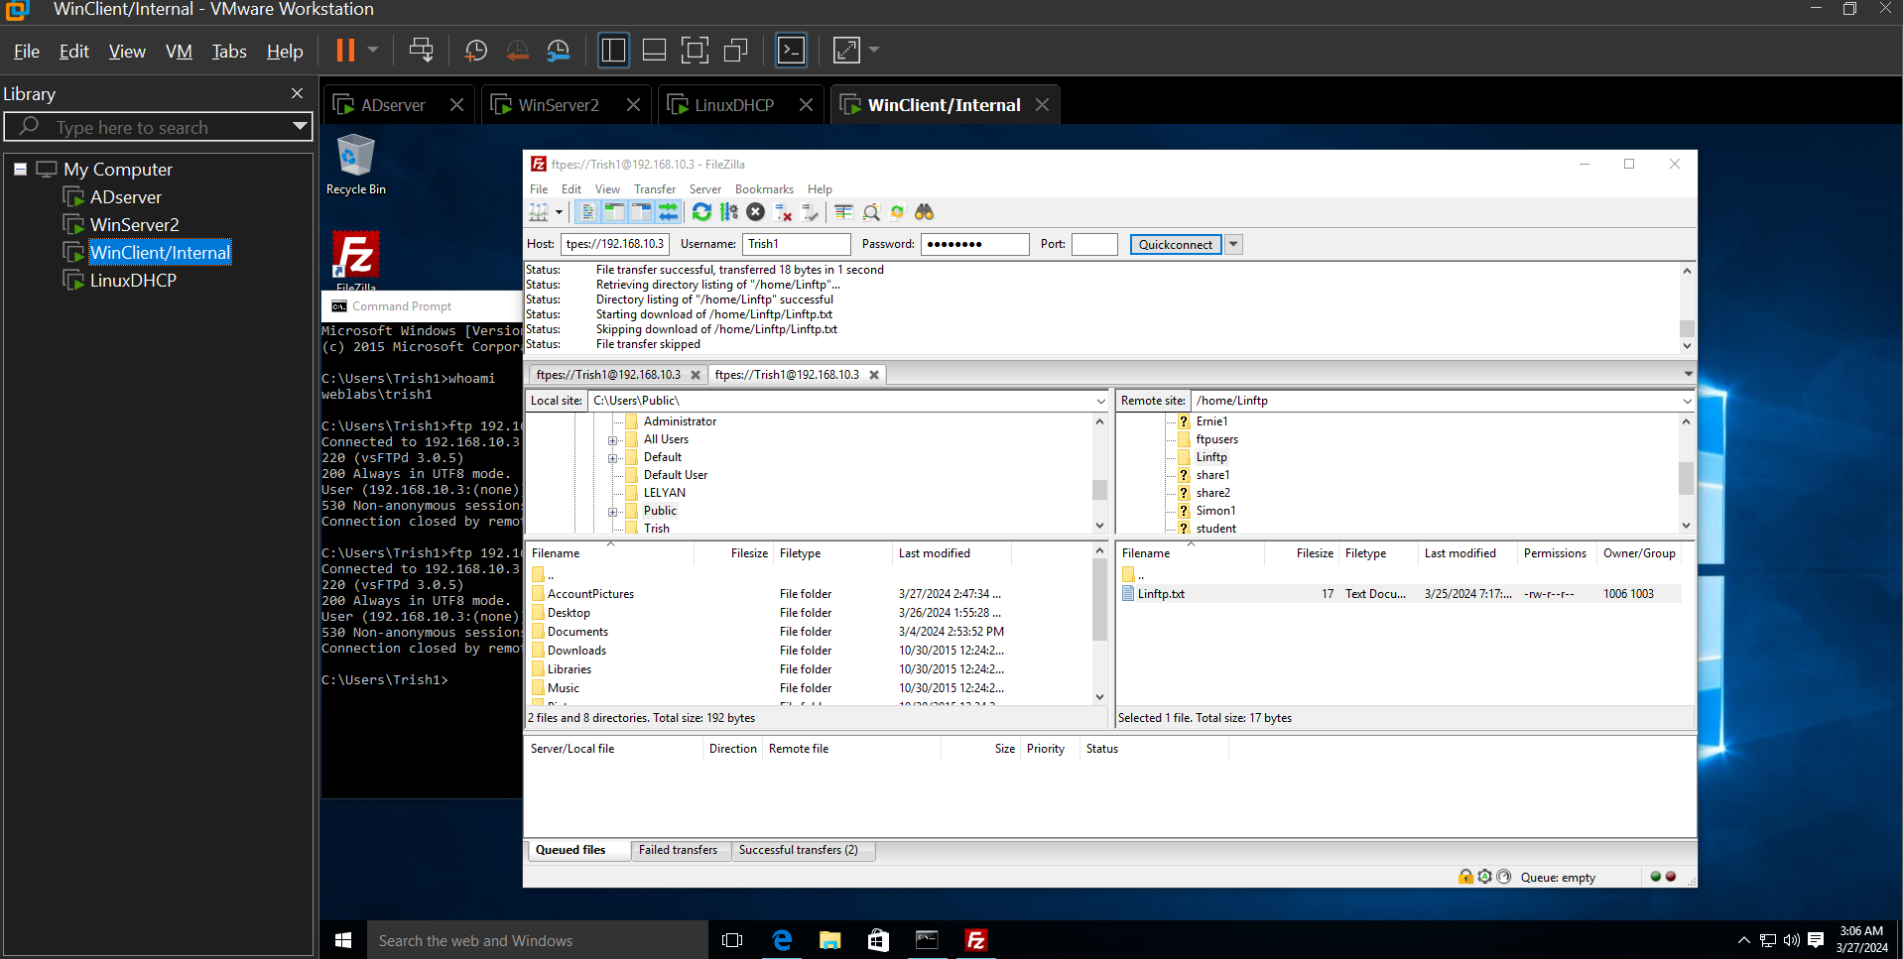

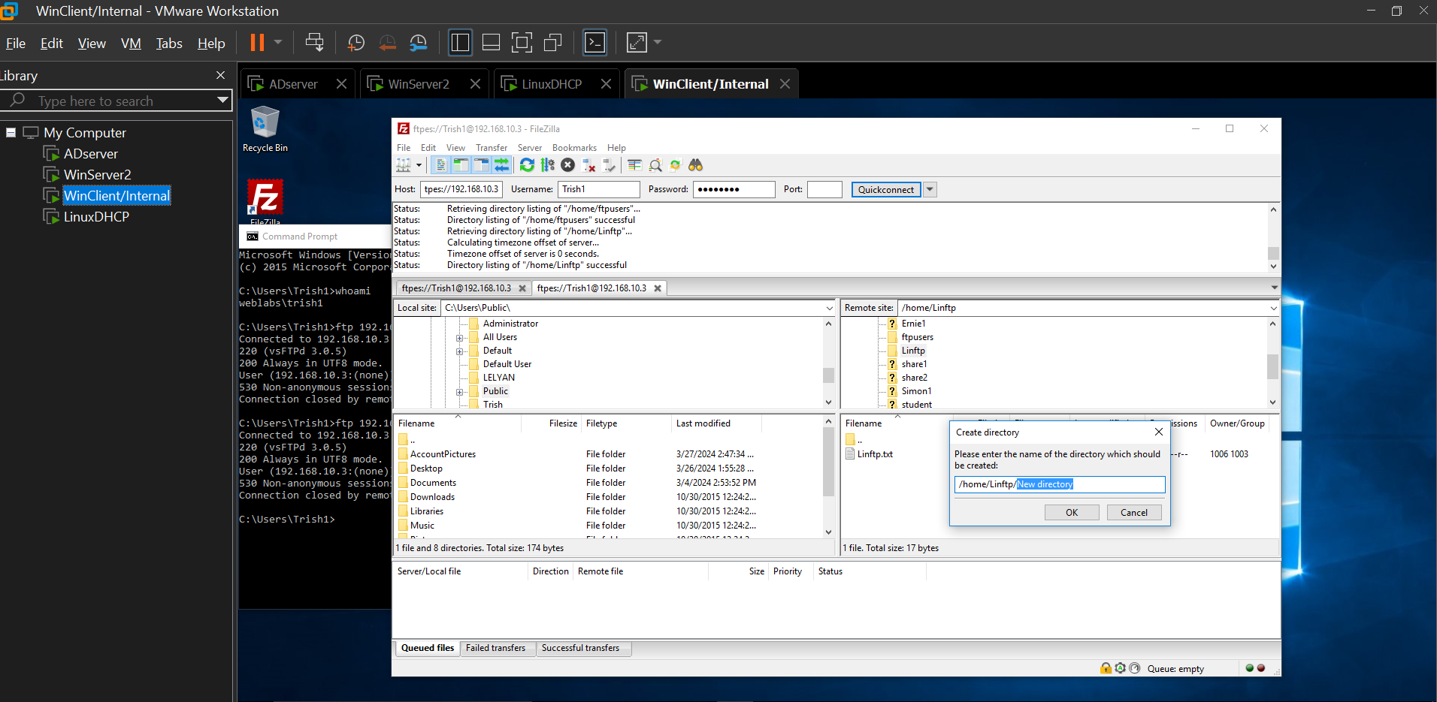

Accessing honeytoo share, able to read but without being able to write to it

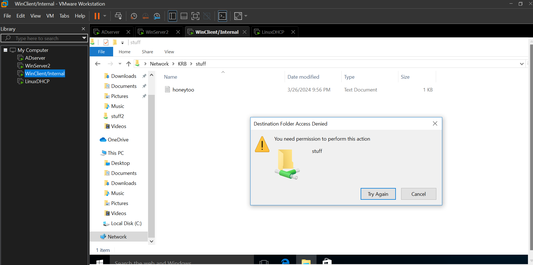

==When logged in or connecting as Ernie==

Accessing linstaff website – should be unsuccessful

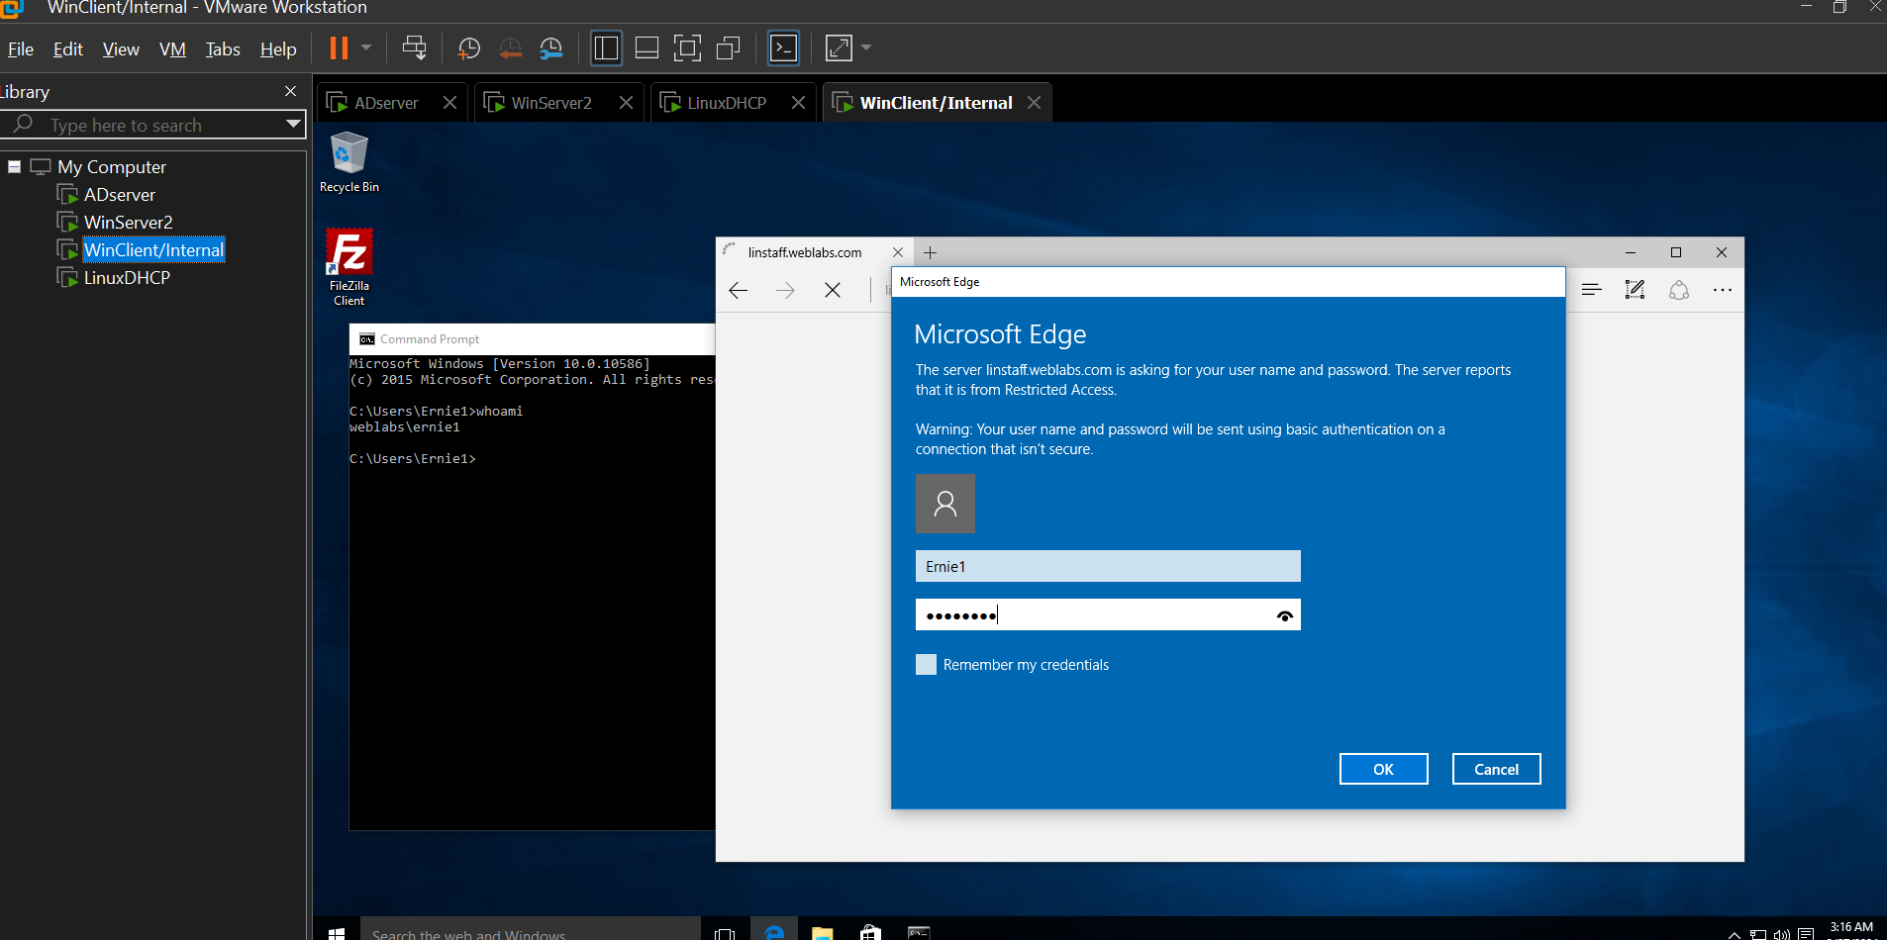

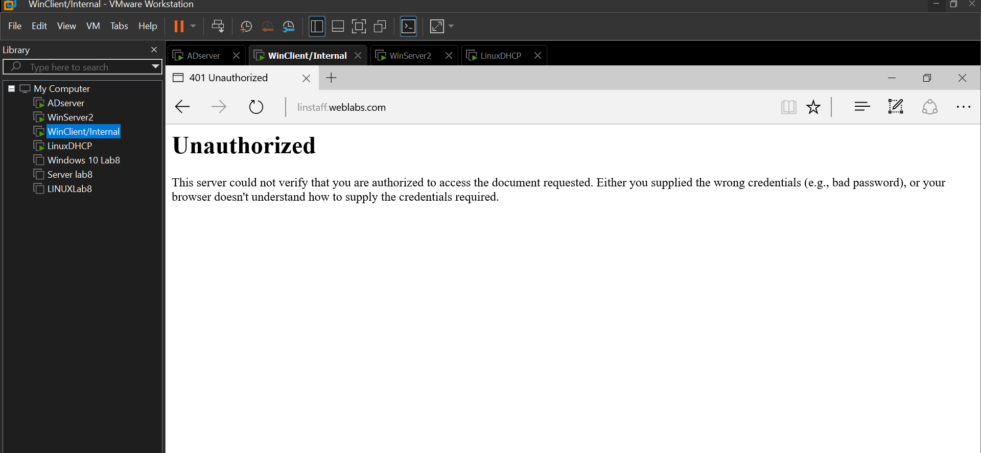

Accessing linwww should be successful

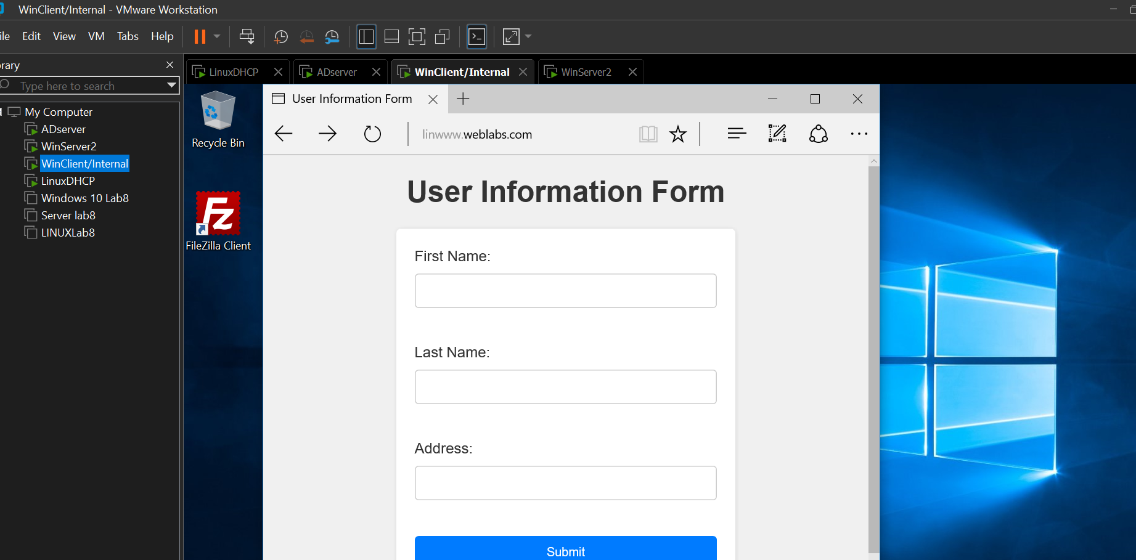

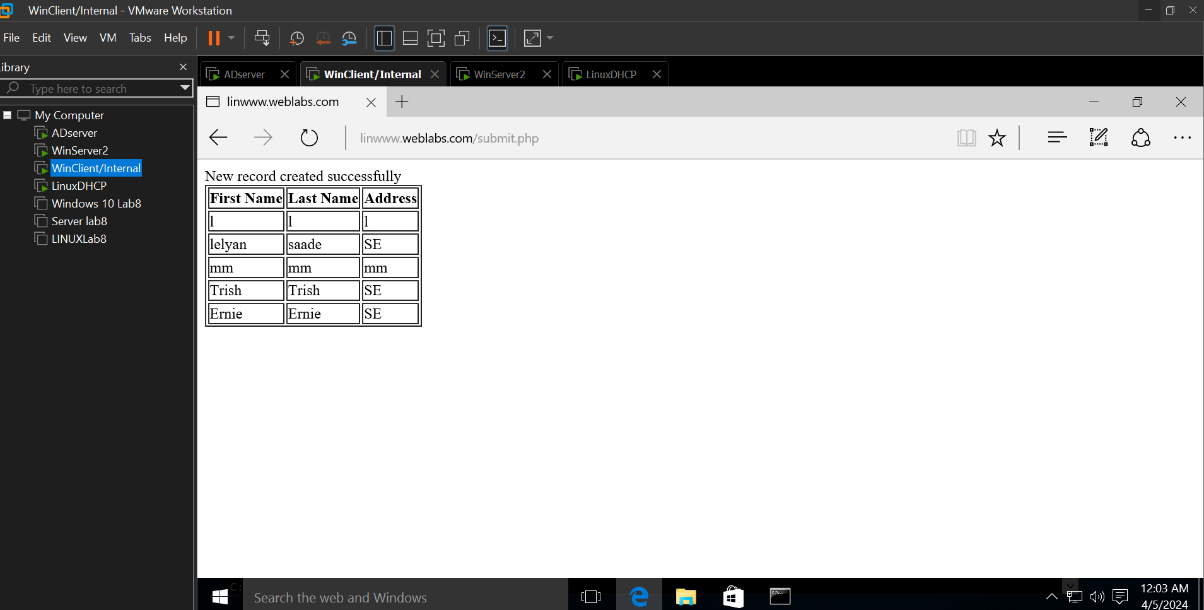

Accessing stinger share – can read and write

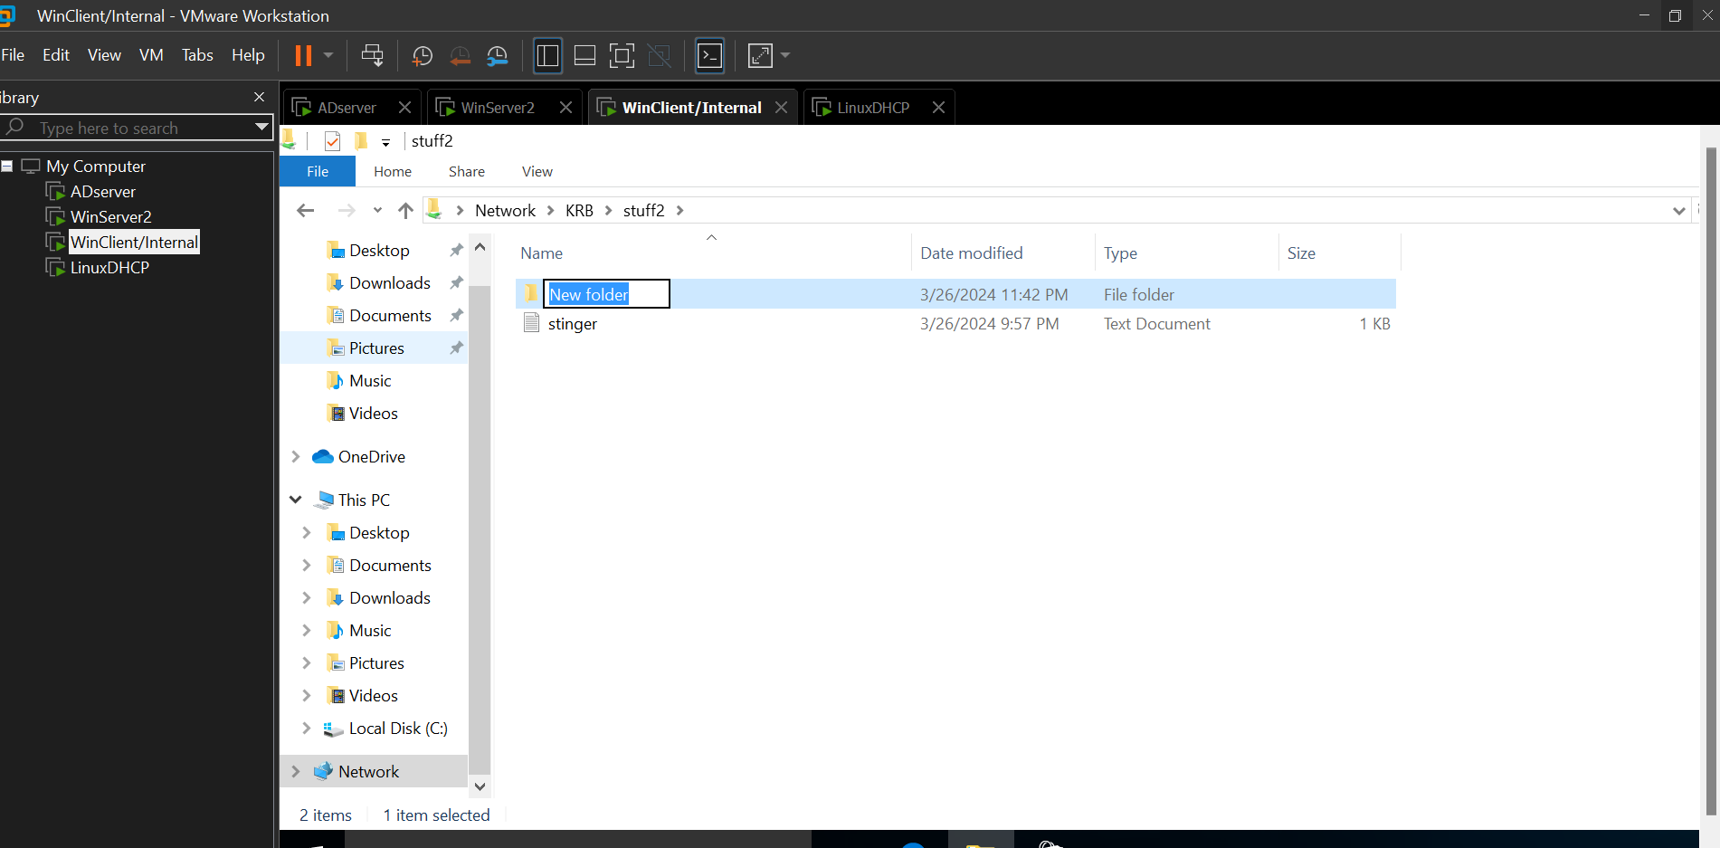

Able to putty to linux and logon with his domain account

